JAVA ROCK PAPER SCISSORS LAB REPORT

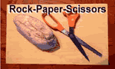
Name and Student ID: Jibran Akhter, 1073973
Date project completed: 3/16/2024
Platform (Mac, PC, Linux, etc.): Windows 11 PC
Development system (onlineGDB, NetBeans, Eclipse): onlineGDB

OBJECTIVES
Input player inputs using cout/cin (for C++) or printf/scanf (for C)
Use nested if/else if/else statements to determine the outcome of the game
Identify illegal inputs from the user and display an error message

PROJECT DESCRIPTION
Chapter 3 Programming Project #1 (page 170 8th Edition, page 172 9th Edition)
Write a program to determine the winner of the rock-paper-scissor game. Each of the two users types in either R,P, or S. The program then announces the winner as well as the basis for determining the winner: Paper covers rock, Rock breaks scissors, Scissors cut paper, or Nobody wins. Be sure to allow the user to use lowercase as well as uppercase letters. Your program needs to include a loop that lets the user play again until the user no longer wants to play.

TEST DATA TABLE
Fill in the Actual Results after you have run and tested your program
TEST DATA VALUES | EXPECTED RESULT  Computed values before  the program is run | ACTUAL RESULT  Fill in the output displayed  by the program
  Player 1 | Player 2
 | It’s a tie !  Player 2 wins !  Player 1 wins !  Player 1 wins !  It’s a tie !  Player 2 wins !  Player 2 wins !  Player 1 wins !  It’s a tie !  Invalid input for player 1  Invalid input for Player 2 | 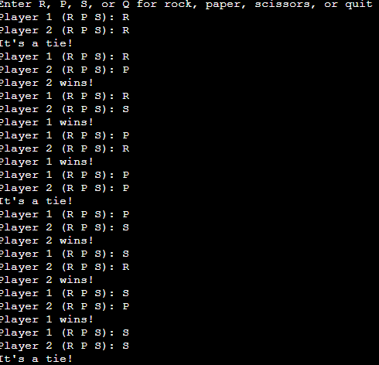  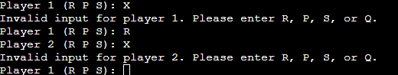
  R | R
  R | P
  R | S
  P | R
  P | P
  P | S
  S | R
  S | P
  S | S
  X | R
  R | X

DISCUSSION
What did you do to develop the program? ("Followed the Directions" is not a complete description)

To make the Rock Paper Scissors program in Java, I started with the code my professor gave me. I first took a good look at it, understanding how it worked. Then, I tweaked it a bit here and there to fit what we needed. After that, I tested it out to make sure everything was running smoothly. Finally, I ended up with a version that combined my professor's code with the changes I made to make it just right.

What problems did you have and how did you overcome the problems?

Great! Now, based on the modifications made to your professor's code, you can answer the question as follows:

While experimenting with my professor's provided code for the Rock Paper Scissors game, I encountered an issue where invalid inputs were not handled correctly, resulting in unexpected behavior. To address this, I refined the input validation logic within the code to prompt users to re-enter their choices if they were invalid. Additionally, I added the missing comparison logic and result display to ensure the game accurately determined the winner and provided the appropriate outcome. These adjustments improved the functionality and user experience of the program, allowing for smoother gameplay and eliminating errors associated with invalid inputs.

SCREENSHOTS
Capture only the portion of the screen that shows the calculator or program output. Do not capture the entire screen even though it may also contain the program output. If I need to zoom in on a screenshot, sometimes the image resolution is so poor that I am not able to read it. If this happens, I will ask that you resubmit your lab report. Refer to these instructions capturing screenshots and pasting them to the lab report


For the Mac
- hold down command + shift keys and press the 4 key
to get a screenshot of a selected area of the screen
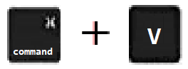
- Use the mouse or touchpad to select the desired area of the screen you want to save
- use command+V to paste into the lab report

For Windows

- use Microsoft's Snipping Tool by holding down the
Windows and Shift keys and tapping the ‘S’ key

- Use the mouse or keypad to select the part of the screen you want to save
- use Ctrl+V to into the lab report.
Place your screenshots here
Show screenshots showing each of the nine winning possibilities and one that shows what the program does with an illegal input. You should have ten screenshots.

Place your TEN screenshots here.

